Networking in docker

Docker container can ping to base os as well using the gateway ip.

Command to check available networks insde docker

Docker network ls

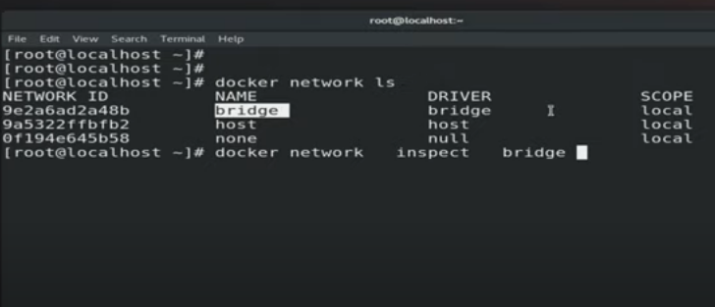

Docker network inspect bridge

This command gives the detailed info. About network created by docker

Cat /etc/resolve.conf

This command stores the nameserver(dns) info.

IPAM(ip address management) is a database that stores the info. About your network.

Bridge is also called switch but with software

We can also create a router using a software using SDN also known as bridge.

So that’s why bridge will do the work of switch and router.

By default docker container lauched in bridge network